Overall Belonging (Descriptive Statistics)
- What the numbers say:
  - Mean: 7.70
  - Median: 8.00
  - Mode: 8.00
  - Standard Deviation: 1.58
  - Only 9.40% report a 5 or lower
- What does this mean?
  - Students report a strong sense of belonging, averaging a 7.70 out of 10
  - The median & mode of 8 indicate that most students are at the high end of the scale.
  - The low standard deviation of 1.58 suggests respondents are fairly consistent.
  - Fewer than 10% of students report low belonging (5 or below), indicating that most students feel positively connected to campus.
- Executive takeaway:
  - Belonging is broadly strong, with a small but meaningful minority experiencing low connection.
Top Dislike Themes
- What the numbers say:
  - Most common words: loud/noise, small rooms, expensive, kitchen, parking, and food.
- What does this mean?
  - The most common concerns relate to noise levels, room size, cost, and shared facilities.
- Executive takeaway:
  - Operational and environmental factors such as noise, space, and cost are more salient than interpersonal issues.
Key Predictors of Belonging
- What the numbers say:
  - Strong positive predictor: 0.685 (p < 0.001)
  - Other significant positives: 0.336, 0.184, 0.259
  - One negative predictor: -0.125 (p = 0.84)
  - R² = 0.0360
- What does this mean?
  - Several community-related factors significantly predict students’ sense of belonging.
  - The strong predictor (β = 0.685) shows a substantial positive relationship, indicating that improvements in this area are strongly associated with increased belonging.
  - Most predictors are statistically significant (p < 0.05), indicating reliable relationships.
  - The model explains 36% of the variations, which is strong for a survey-based social data.
- Executive takeaway:
  - Belonging is not random; it is strongly associated with specific actional residential experiences.
Belonging by Residence Hall
- What the numbers say:
  - Scores range from 7.34, the lowest, to 7.97 the highest.
  - The spread is small, about 0.60 difference.
- What does this mean?
  - Belonging is relatively consistent across residence halls, with averages ranging from 7.34 to 7.97.
  - Some variation exists; no hall falls dramatically below the campus average. Suggesting the overall stability across resident communities.
- Executive takeaway:
  - No hall is in crisis, but there is an opportunity to raise overall community perception levels.

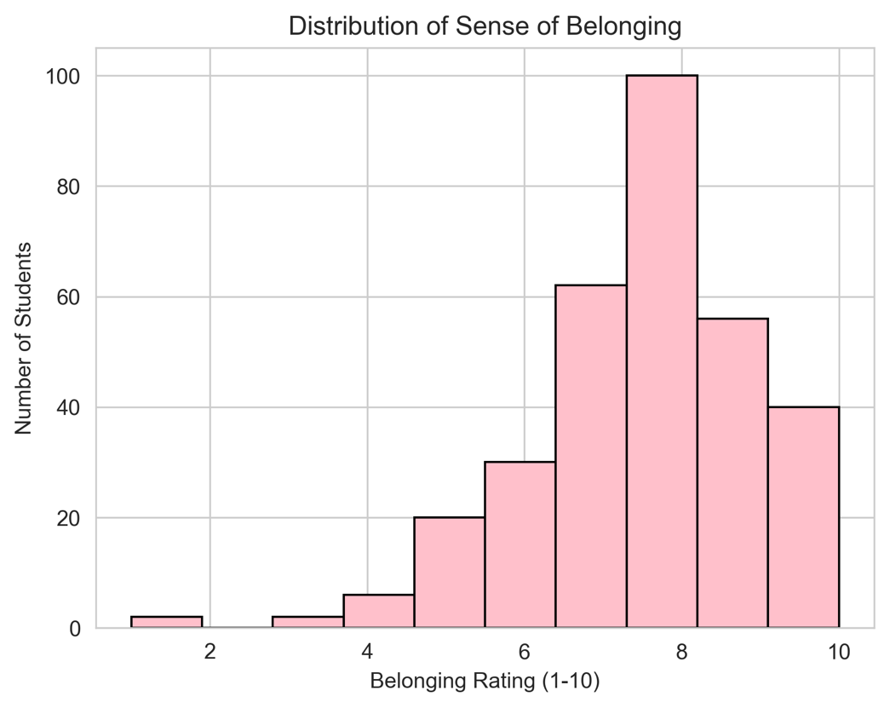
This chart shows how students rated their overall sense of belonging (1-10 scale). Most of the ratings fall between 7 and 9. Very few students rated belonging below 5. This distribution is slightly skewed to the left, toward the higher end. Overall, students report a strong sense of belonging. The clustering around 8-9 suggests that most students feel connected to the university’s community.
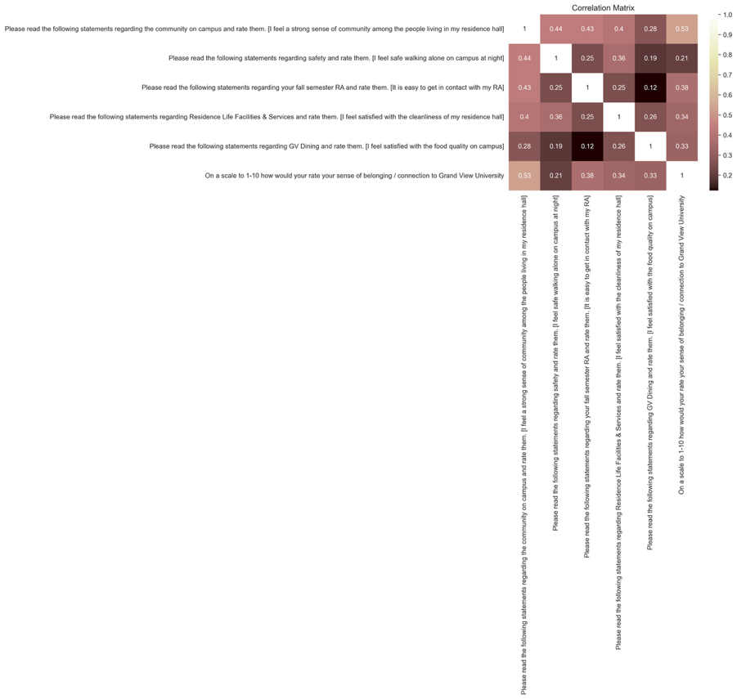
The heat map shows how different factors relate to each other, especially how they connect to overall belonging. The strongest correlation is about 0.53, the sense of community in the residence hall. Moderate correlations are observed for RA accessibility (about 0.38), cleanliness (about 0.34), dining satisfaction (about 0.33), and safety at night (about 0.21). Community within residence halls is the strongest predictor of belonging. Safety and dining do matter, but not as strongly. There is no extremely high correlations, meaning belonging is influenced by multiple factors rather than just one.
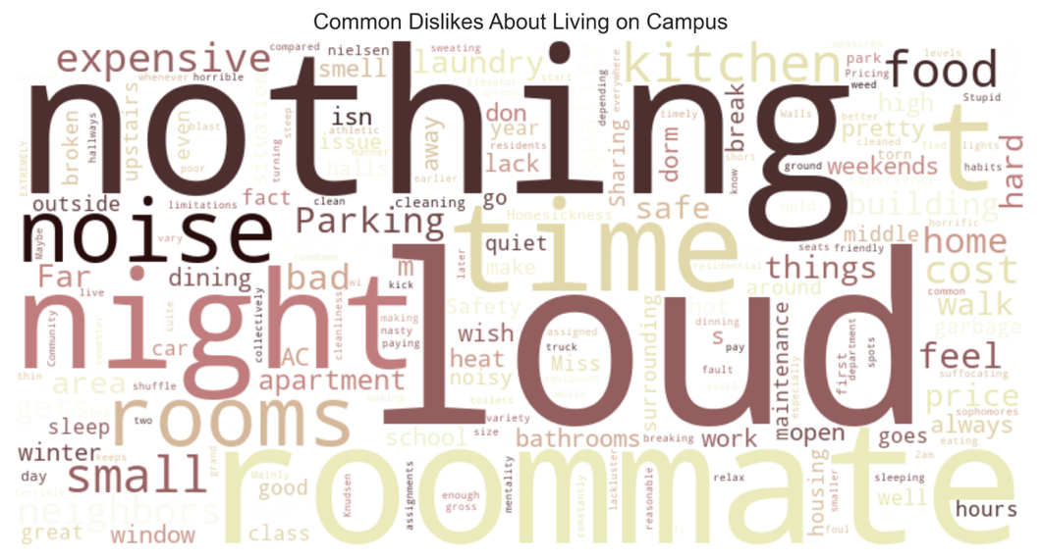
The word cloud shows numerous things. Larger words mean they are mentioned more frequently. The most common themes are noise, roommates, nothing, food, time, cost, and small rooms. This means many housing sources of frustration include noise levels, roommate conflicts, food quality, cost of living, and room size. It is interesting that “nothing” appears large, meaning the study reported no major complaints.
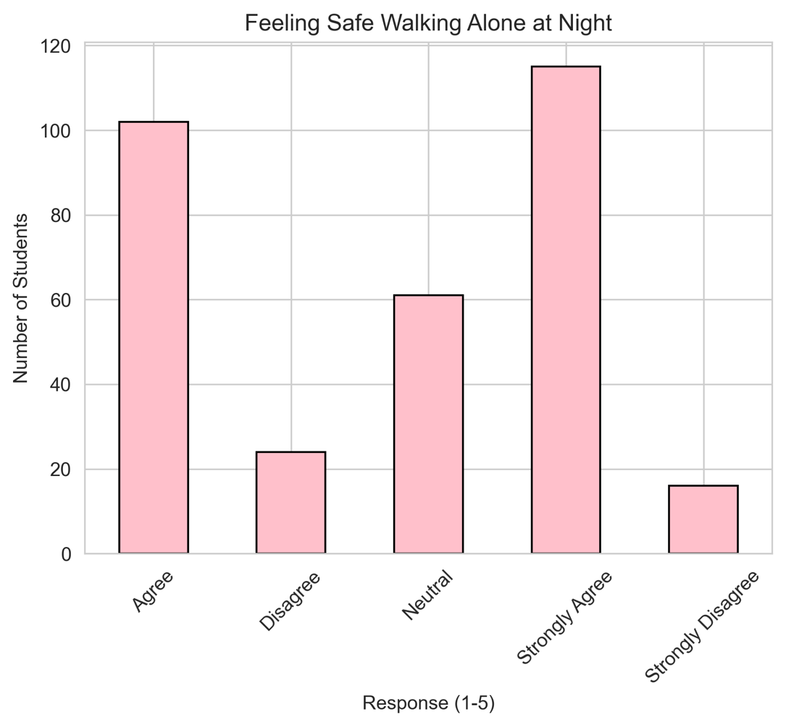
The majority of students strongly agree or agree in general that they feel safe walking alone at night. There is a moderate group that is neutral and small minority disagrees and strongly disagrees. Most students feel safe walking along at night, which contributes positively to the overall campus experience. However, a noticeable neutral group suggests some uncertainty.
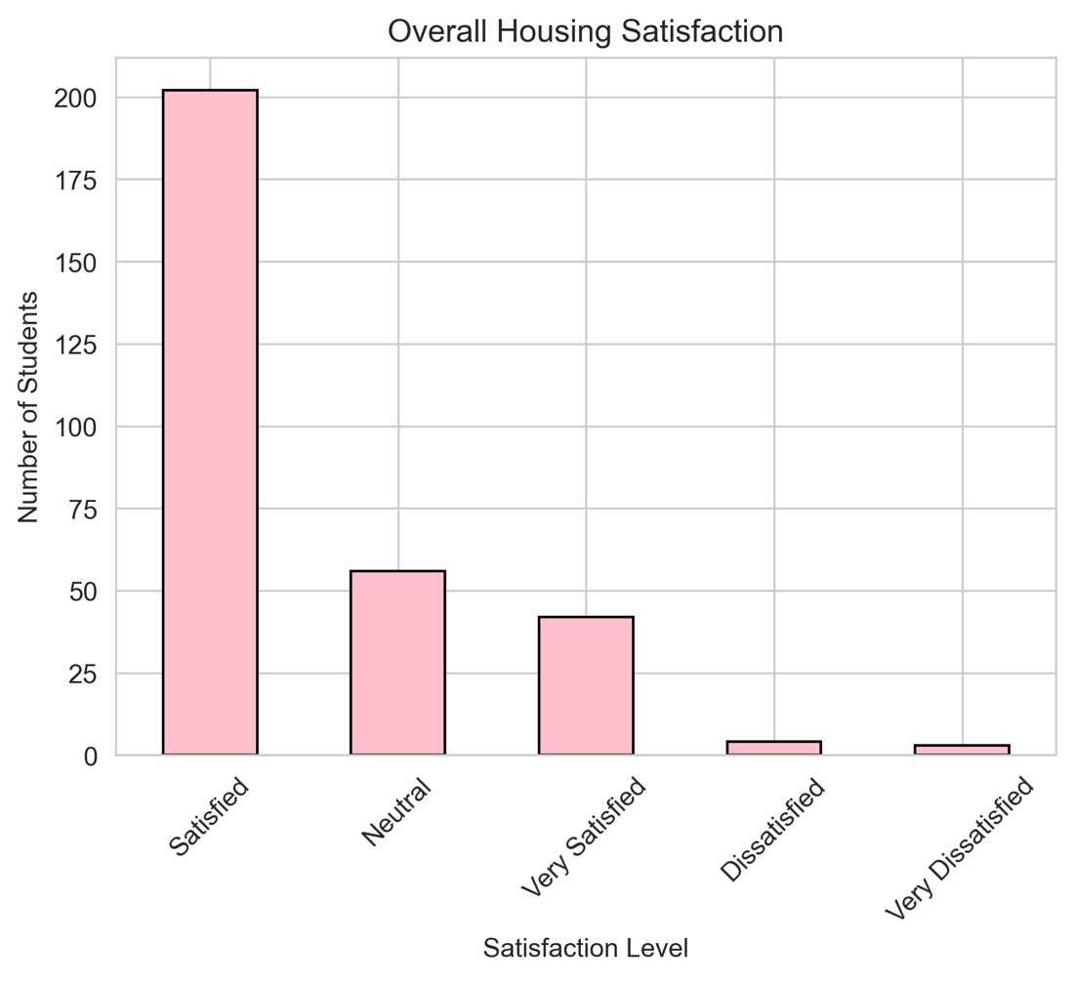
Overall, housing satisfaction, the largest group is satisfied. Then it’s neutral and very satisfied, then a small group is dissatisfied and very dissatisfied. Overall, housing satisfaction is high. Dissatisfaction levels are very low, reinforcing the earlier positive belonging scores.

